ECOR 1010 - DAY 1

Glenn McRae - Office in Physics (Hertzberg 4432)

put CHEM1101 in Email in subject

Office Hours: TBD

3D Print Manager: Stephan Biljan – 2230ME
Grading:
Reports (Laboratory Assignments): 17.5 %
Reverse Engineering Project: 10 %
SafeSmart: 2.5%
Midterm Exam: 20 %
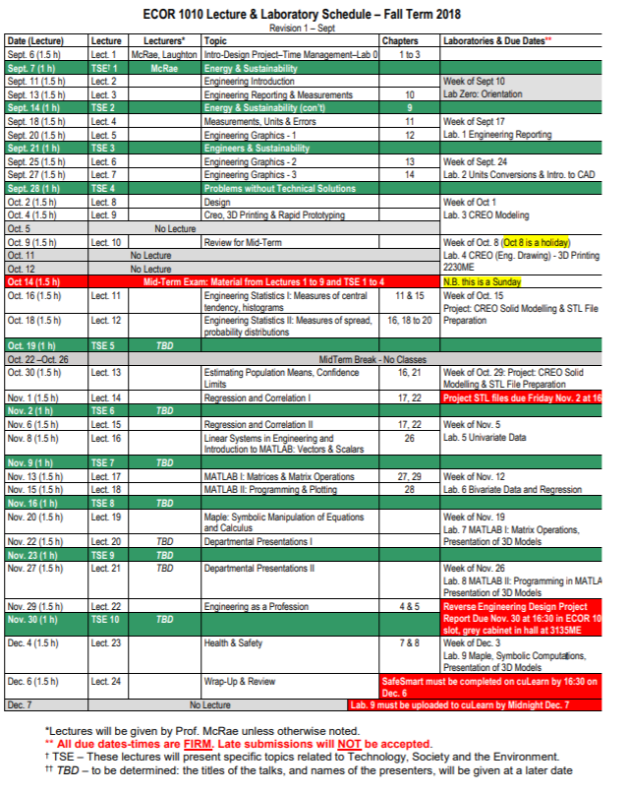
Final Exam: 50 %
There is the possibility of obtaining 4 % bonus marks if more than 7 Laboratory Assignments are completed with a mark of greater than or equal to 5/10, as described in ‘Note #1’ below.
Labs:
MUST complete 7/9 labs
Fewer than 7 means a “FND” grade
– More than 7, take best 7 marks
– If you get ≥ 5/10 on 8 labs, get a bonus 2 %
– If you get ≥ 5/10 on 9, get an additional 2 %
LABS:
Labs assigned one week are due with the first 30m of the next lab period or they will be LATE
MIDTERM: October 14, 2018
-1 hour
-30 multiple choice
ECOR DESIGN PROJECT:
We are going to take an object, reverse engineer it by taking an existing product, measuring and evaluating it, and creating CAD database to reproduce it.
Open ended but marks based on reasonable fulfillment of the requirements.
You must find a group of THREE members.
Project requirements:
1. Determine (and indicate in your report) the purpose of the part. What is it called?
2. Measure all of the important dimensions;
3. Determine the material the part is made from;
4. Describe the manufacturing process required to go from raw material to finished
part;
5. Identify one failure mode for your part;
6. Describe the value and benefit of your redesign in approximately 200 words,
considering creativity, usefulness, part integrity, and aesthetics;
7. Generate a engineering drawing of the part, including all relevant dimensions;
8. Generate a rendered solid model of the part to include in the Design Report, and
a scaled model converted to STL* file format;
9. Submit the STL file for printing on one of two 3D printers.
CAD IT
HANDING STUFF IN:
For project: reverse engineering;
- STL files: 4:30pm Friday, November 2, 2018
- Report: 4:30om Friday, November 30, 2018 (ECOR 1010 slot in the metal cabinet outside room 3135ME)
DEADLINES:
• Lab assignments are due 30m after start of next Lab session. (Electronic copy posted to cuLearn)
• Design Project STL file due 16:30 Friday November 2, 2018
• Report (hardcopy in ‘cabinet’) due Friday,16:30 November 30, 2018
• SafeSmart shall be completed by 16:30 Thursday, December 6,
2018
ECOR 1010 Lab 0:
Log onto CuLearn
Go to ongoing courses’ category
Click on SAFE questionnaire and do it.

